**Moderate to Severe Evaluation**

Sample_id : **J4RHR9(Dog)**

Link:<https://release.animalbiome.com/pet/assessment/report/appendix/ec6d592d-9940-4c21-971e-c216c4d3f6d6>

Cats and dogs:

Any two of the following:

(

High Red Flag Megamonas OR (failed)

High Red Flag Sutterella OR (failed)

High Red Flag Collinsella OR (failed)

Low Red Flag Bacteroides OR (failed)

Low Red Flag Blautia (failed)

);

OR

Dogs:

8 or more yellow flags (passed)

OR 8 or more red flags (failed)

High red megamonas,suttrella and collinsella failed.

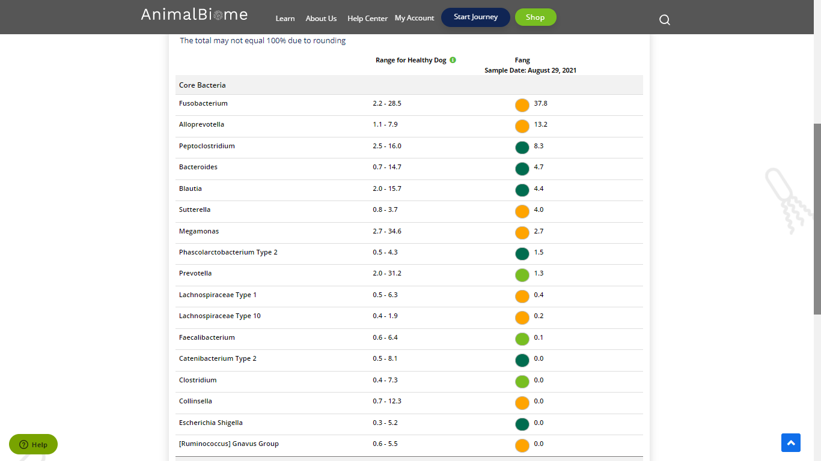

Low group evaluation:

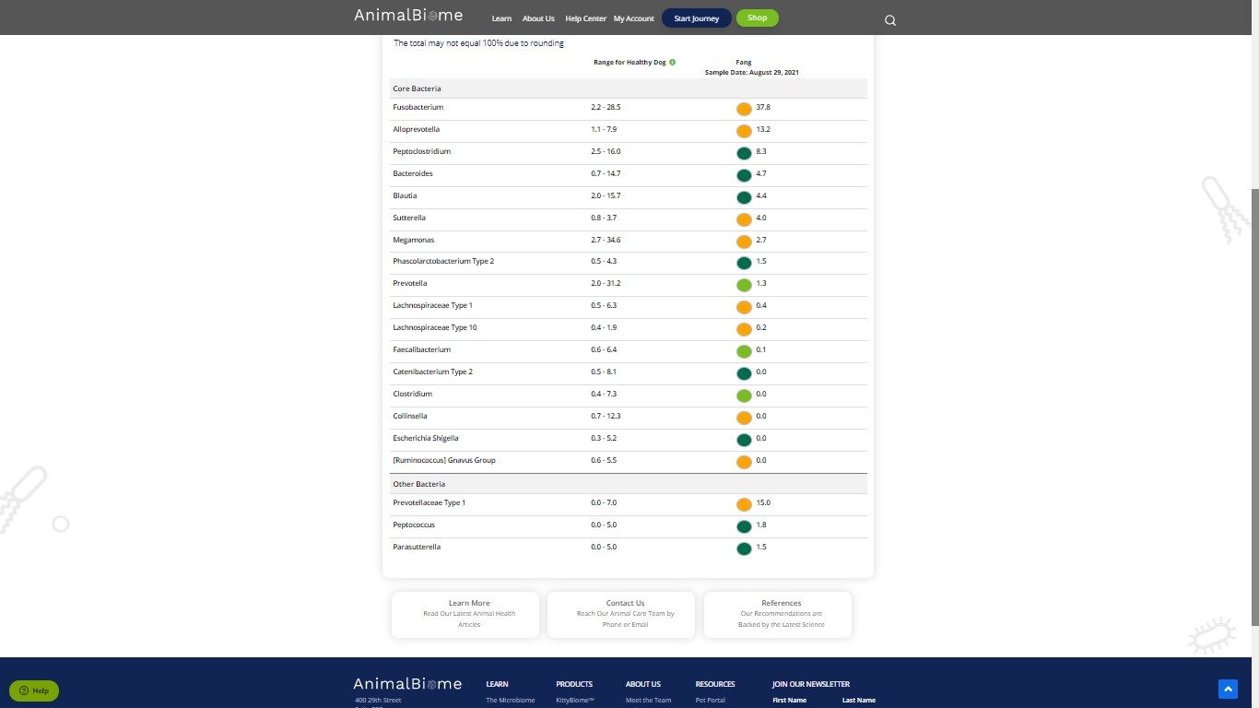

low red blautia : failed.

Low red bacteroides : failed (all conditions failed ) in the primary group.

Total yellow flags : 9

Red flags : 0

The result : **False True False**

Moderate to severe results:Pass

Expected result : **Moderate to severe**

Achieved result : **passed.**

